Intermediate Algebra Lecture 12.4: Introduction to Graphing and Solving Logarithmic Functions

Solve:
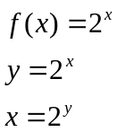 For an Inverse

Solving for “y” can be achieved by using
Logarithmic notation

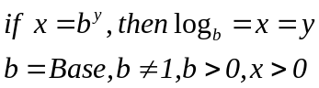
b=Base, b

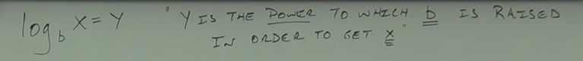

Example
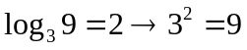
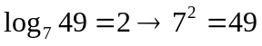
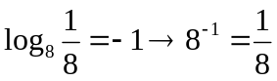
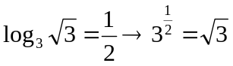
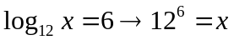
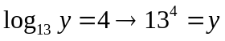

Example
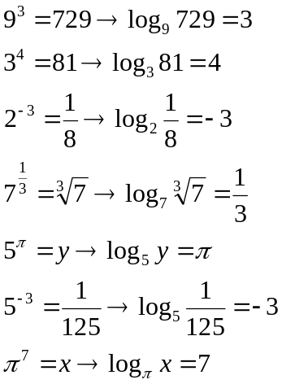

Example
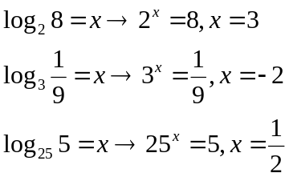
Example
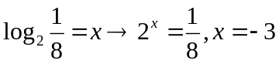

Solving Logarithms
Change to exponential form or logarithm form
NOTES
- 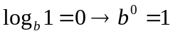
- 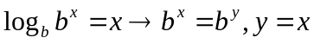
- 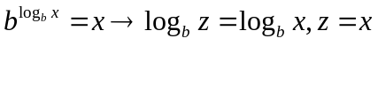

Example
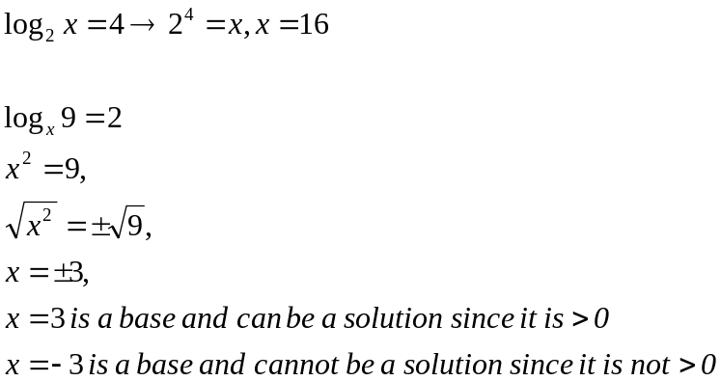

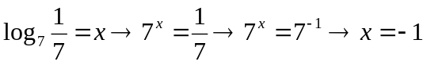
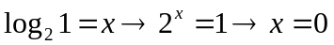

Example
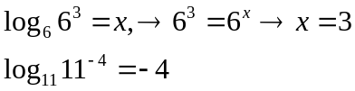

Example
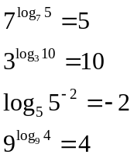

Graphs of Logarithms
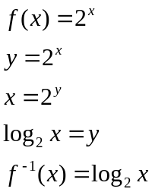

Logarithmic Functions (inverse of an exponential function)
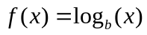

These exponential graphs approach the x-axis but never reach it.

